332

ATTRIBUTES OF LOCATION AND HOUSING PRICES IN OSLO:
A monetary valuation with spatial configuration in mind
__________________________________________________________
ABSTRACT
In this paper, we use a hedonic pricing approach, as defined by Rosen (1974), to estimate the effect of attributes of location on marginal apartment prices in Oslo, Norway, while controlling for structural factors of the apartments. To be able to address urban planners and designers, we aim to use variable specifications that can be interpreted and used in practice, in contrast to area-based measures, simple buffer analyses, or straight line distance measures. This will also allow to test the effect of space syntax measures on housing prices when more precise specifications of attributes of location are used. We conduct different types of accessibility measures with the place syntax tool (PST) using non-aggregated geographical data, including 42,669 apartment sales on address point level, and a hand drawn axial map. An ordinary least square (OLS) model specification is used, and additional statistical analysis to capture patterns in the data to ensure robust results.

It is estimated that spatial configuration has an impact on prices in the apartment market in Oslo, which is in line with previous research in other cities. Most robust is the network integration on radius 30. We can also conclude that access public transit is positively correlated to apartment prices, while private transit is negatively correlated. Access to open water and to the natural reserve Marka is positively correlated with apartment prices.

We believe that we have taken a step further in estimation of hedonic prices due to non-aggregated data and network based measures, and that these additional metric measures even more proves the impact configuration of space has on people’s perception of their surroundings.
KEYWORDS
Hedonic pricing, space syntax, attributes of location, urban design quantification
1. INTRODUCTION
Market values of urban planning and design are usually hard to value, since they cannot be bought or sold. Beyond the construction cost and sales values of buildings and land, very few of the things that urban designers contribute to are ever given a monetary value. Instead, the designs are given other values such as aesthetical, social, and ecological values. Although, these usually are the values sought for in visions, they are rarely given any weight in the city budget, and consequently do not find expression in the implementation of urban development projects. Our study starts from the proposition that if planners can assign monetary value to qualities of urban design, the implementation would follow vision more closely. Given this, it is of high interest to estimate what value urban design creates, whether it is statistically significant or not, and if significant, whether positive or negative.

To manage this task, two problems have to be solved: quantifying urban design and valuing non-market goods. Space syntax methodology possess interesting elements that help solve the challenge of quantifying urban design. If we look at urban design as the placing of destinations and structuring of space, we can interpret it as relations between destinations or between spaces themselves, from here on referred to as attributes of location. Using the axial and segment map as our models of space gives us the opportunity to measure different aspects of spatial configuration (Hillier and Hanson 1989; Hillier 1996). Furthermore, we include destinations in the city to be able to quantify attributes of location connected to the dwellings using the place syntax tool (Ståhle, Marcus, and Karlström 2005). With the axial and segment map as representations of space and with the addition of geocoded destinations in the city, we can quantify the attributes of location to fit the model. This is also a matter of how to subcategorise urban design into precise measures of accessibility and decide which to include or leave out.

The challenge of valuating non-market goods can be solved in two principally different ways, by examining stated or revealed preferences. The stated-preferences approach consists of polls, questionnaires, or experiments to determine willingness-to-pay(WTP) for amenities, while revealed-preferences consists of analysis of actual choices or purchases made (Palmquist 2005). Examples of stated-preference approaches include contingent valuation, multiple price list, choice experiments, experimental auction, and field experiments. This study uses a revealed preference method called hedonic pricing, to estimate marginal WTP. In short, it assumes that the value of a good, in this case, an apartment, is determined by the values of its characteristics, for example, size of the apartment (Rosen 1974). By using regression, a hedonic pricing model estimates the marginal values of each measured characteristic. Because we are using a revealed-preference data set of actual apartment sales, the marginal values are the marginal WTP’s of each characteristic. In most of the studies using this method, the dependent variable is the price of sold dwellings in one or another form.

2. BACKGROUND
Hedonic models commonly work as basis for policy and decision making in city development issues (Whitehead 2012), but usually in fields adjacent to urban design and therefore they do not have a focus on investigating urban design principles. A Norwegian exception is the study of Sjaastad, Hansen, and Medby (2008). Historically, this lack of focus on urban design principles might be explained by lack of computer power or geographical data accessibility.

The theory behind hedonic modelling posits that the housing characteristics used in the model should capture the perceptions of the buyer (see Rosen (1974), Palmquist (2005) and Baranzini et al. (2008)). However, we see a clear gap between what is measured and tested in hedonic modelling and how the same attribute of location is actually perceived. As an example Palmquist (2005) takes pollution, which is very commonly used as a variable in hedonic models but is arguably not really perceived by the consumer. Pollution measured as number of particles in the air, has been estimated as negatively correlated to housing prices, but unless it is badly polluted as in some cities in China or India, is impossible for a consumer to perceive small variations in otherwise good air quality. This means that the measure is correlated with what is perceived, but not with what the perception is of. In the same fashion, many attributes of location are measured as objective measures that are hard to link back to consumers’ awareness, which in the end is what the method should estimate. This discrepancy, as we see it, between theory and practice has a lot to gain from space syntax methodology, where the cognition and the human perception of space is a part. Not only can attributes of location be made out of pure space syntax measures, already examined by Chiaradia et al. (2009), Law et al. (2013) and Yang, Orford, and Webster (2016), but also the place syntax methodology can help us be more precise in specifying network measures with attractions closer to how consumers’ perceive it. Only by making the supposition that by measuring attributes of locations through networks that people moves via, we capture how people perceive it to a greater extent and therefore bring new knowledge to the field. In an ongoing systematic review over recent published hedonic studies using accessibility measures in GIS by Heyman, Law & Berghauser Pont (2017), it is shown that there is a broad spectrum of amenities measured but that the specifications of the measures often are quite simple compared to what is preferable to capture perception. Some studies in the grey literature uses the specifications of accessibility measures with a similar approach as we intend in this paper (see Heyman and Manum (2016) for a description of relevant studies).
3. METHOD
This research examines the relationship between apartment prices and attributes of location in the municipality of Oslo in Norway. In this article, we choose to categorise the explanatory variables in the hedonic model into structural and locational variables. The first category refers to characteristics tied to the physical shape and structural measurements of the apartment, and the second category to characteristics tied to the geographical location of the apartment. Thus, locational variables are a set of measured attributes of location. The approach is to use non-aggregated geographical data to perform network based spatial analysis in GIS to measure these attributes of location and furthermore include them in a hedonic model to estimate their individual impact on the marginal apartment price. We first describe the data and sampling procedures and subsequently describe the variable specification and econometric modelling.

Figure 1. An overview of the urban part of Oslo municipality with the fjord in the centre and natural reserves, Marka, in the north and southeast. The axial map is showing network integration on radius 30 with the highest values being darker.
3.1 Data and sampling

Our data consists of, initially, 42,669 sales of apartments in Oslo between and including 2007 and 2015. The 2007-2015 period is chosen because our locational variables are based on geographical data extracted from within that period. We use the geographical data to proxy quality and quantity of attributes of location in the entire 2007-2015 period, without modification. The sales data was provided by Ambita AS and originally based on two data sets combined. Firstly, the sales reported by realtors to the Norwegian tax agency (Skatteetaten) and secondly, structural characteristics for all apartments in land survey registers (Kartverket). The set included structural characteristics relevant to regression analyses and are connected to the specific apartment and sale price we use as dependent variable.

The resolution of the sales data, is at the address point level, which means a point in space at the entrance of every dwelling. All other geographical data follows that pattern of non-aggregation, apart from socioeconomic data, which we could only retrieve at the level of census tracts. Because we are able to construct non-aggregated and very high-resolution geographical data we can minimize the effect of modifiable areal unit problem (MAUP), described by Unwin (1996).

In our measuring of the attributes of location we used geographical data on a variety of features in the city. Most of the data we obtained from the planning and building agency (Plan- og bygningsetaten, PBE) and the agency of urban environment (Bymiljøetaten) in Oslo municipality. In order to measure the attributes of location we also needed the record of all businesses in Oslo from the Statistics Norway (SSB). From the same source, we retrieved the socioeconomic data on income, employment and education.

The axial map that we used for space syntax analyses was hand drawn and given to us by the consultancy Spacescape in Stockholm and was further developed by us.

We created a set of criteria to remove what we believe were errors in the data: (1) sales for less than NOK 200,000; (2) a price per square meter that is higher than 200,000 NOK/m²; (3) an apartment that is smaller than 10 m².

3.2 Locational variable descriptions
A general principle has been to use network distance as opposed to straight line distance or area based measures, which corresponds better to how people use and perceive the space. As a ground to start from in the selection and specification of variables, we have looked at previous studies in both Oslo (Sjaastad, Hansen, and Medby 2008; Traaholt 2014) and other Scandinavian capitals (Ståhle and Bernow 2011; Lundhede et al. 2013). As origins in the analyses, we used the sales data, as network we used a hand-drawn axial and segment map of Oslo and as destinations we used matching GIS layers.
For the neighbourhood variable socioeconomic index, we received data on aggregate level but for all locational variables, we followed the example of using non-aggregated data and use network distance to measure accessibility. For all locational variables apart from socioeconomic index, we used the segment map as a network to calculate distances. All measures was made with the place syntax tool (PST) developed at KTH and Spacescape AB in Stockholm and Chalmers University of Technology in Gothenburg.
In general people walk five minutes to make most daily errands (Farr 2007), but it obviously differs by type of errand. This gives a walking distance about 300 meters if one uses the average walking speed of 6 km/h (see Gehl (2011), Gehl and Rogers (2010) and Whyte (2001)). To approximate a neighbourhood reach, we sat the network distance to 500 meters, partly to compensate for the assumption that Norwegians are keen walkers, and partly to define a neighbourhood a bit larger than just reaching for the daily errands. Also on the account of radii, we looked at results from previous studies using similar technique and setting (see Ståhle and Bernow (2011) and Lundhede et al. (2013)).
A number of attributes of location are measured as the minimum walking distance to a destination, and even though different specifications have been tested, all benefitted by being treated as logarithmic to compensate for distance decay. The access to highway (WD to Highway Ramp) is specified as the walking distance to any highway ramp. This is to try to capture the effect of car accessibility rather than the noise effect often associated with the actual stretch of the road. A popular destination in Olso is the natural reserve called Marka, it is in fact two different forests, one in the north and one in the south. The variable specification (WD to Marka) is simply the minimum walking distance to either the northern or the southern Marka. Access to open water (WD to Open Water) has been estimated to have a positive effect on housing prices before. In our case, the accessibility to water is specified as the shortest walking distance to a water body with a surface larger than 300,000 m² or water body with a publicly maintained swimming area. Accessibility to park (WD to Park) is measured as the minimum walking distance to publicly maintained green spaces that are treated as parks by the municipality. The shortest walking distance to a nearest primary school (WD to School) is calculated as well. We collated primary schools that were registered on the municipality’s homepage. Access to public transit was tested in many ways, both with different radii and with different destinations to find the best fit.
Spatial configuration has been measured as network integration on radius 3, 12, and 30 and angular choice on the radius 2, 5, and 10 kilometre walking distance. Radii was chosen to capture both local and global characteristics in the spatial configuration. The analysis was made with PST on a hand drawn axial map, which was converted to a segment map for the choice analyses. The values assigned to every point of sale are from the closest line in space, which was done through the FME software.
Amenity diversity has earlier been shown to have an impact on housing prices in Copenhagen (Lundhede et al. 2013). The aim with the measure is to capture the number of different amenities one can reach within a certain distance, but the ways to define it are numerous. In our case, we have chosen to include shops, restaurants, bars, cinemas, art galleries, museums, and libraries that can be reached within 500 meter walking distance from the apartment. However, just to add them together would give a skew measure in diversity, because of their differences in occurrences in the city; there are many more shops than libraries for example. We try to compensate for this by using equation (1):
 | $$\frac{\left(\frac{S}{S_{max}}\right)+\left(\frac{R}{R_{max}}\right)+\left(\frac{B}{B_{max}}\right)+\left(\frac{C}{C_{max}}\right)+\left(\frac{A}{A_{max}}\right)+\left(\frac{M}{M_{max}}\right)+\left(\frac{L}{L_{max}}\right)}{7}$$ | (1)
The data we used to compile the socioeconomic index variable (Socioeconomic index) was level of employment, education, and income. The two first sets we could find on the smaller level of census tract “grunnkrets” of which there are 540 in the research area, while income was obtained on the even more aggregate level of census tract called “bydel” (16 in the research area). To try to make use of all three variables we disaggregated the information of income on bydeler to census tract (‘grunnkrets’), in order not to lose variation from the other two variables in the index. For employment level, we divided the number of employed with the total number of employable within each census tract in order to get a normalised value. In the same fashion we calculated the share of people with a degree from college or university longer that three years within the age of 20 to 64. Income was measured as average yearly income on bydel and disaggregated down to grunnkrets and normalised according to equation (2). The index was set as the average value (between 0 and 100) from the three components.
 | $$z_{i}=\frac{x_{i}-\min{(x)}}{\max\left(x\right)-\min{(x)}}$$ | (2)
All locational variables fitted in the final model are presented in maps in Figure 2 and descriptive statistics in Table 1.

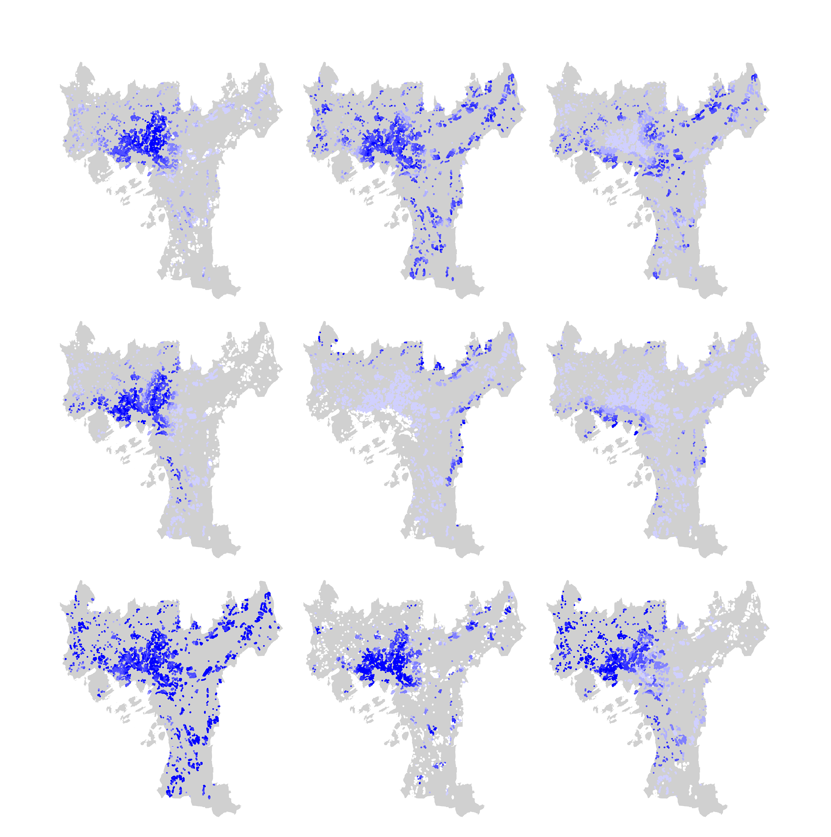
Network integration R30
WD to school
WD to highway ramp
WD to park
Amenity diversity index
Socioeconomic index
WD to water
WD to Marka
WD to tram
Figure 2. Maps of locational variables in Oslo municipality included in the final model. All sales are represented as a point in the map and all intervals are set to equal ranges with blue as high values and white as low.

Variable Expected Sign¹ Mean Median Min Max
log(Per Square Meter Price)² 10.75 10.76 7.17 10.56
Year³ +/- 2011 2011 2007 2015
log(Apartment Living Area⁴) - 4.14 4.14 2.56 5.98
Number of Bathrooms + 1.11 1.00 1.00 5.00
Floor Number⁵ + 3.27 3 1 20
Having Elevator + 0.64 1.00 0.00 1.00
Network Integration R30 + 0.57 0.60 0.23 0.70
log(WD⁶ to Primary School) - 6.36 6.43 3.51 7.90
log(WD to Highway Ramp) + 7.05 7.12 4.06 8.81
log(WD to Tram) - 6.43 6.35 2.56 9.26
log(WD to Marka) - 8.07 8.28 3.57 8.96
log(WD to Open Water) - 7.46 7.73 2.13 8.70
log(WD to Park) - 5..40 5.52 2.39 7.41
Amenity Diversity Index + 7.00 3.92 0.00 62.07
Socioeconomic Index + 54.19 55.57 12.43 85.91
Notes:
¹ Expected sign of the coefficient corresponding to a variable.
² Unit: NOK/m².
³ The year that the apartment was sold.
⁴ Unit: m².
⁵ The floor number that an apartment is located.
⁶ WD stands for walking distance. It is the shortest walking distance, for example, to a nearest primary school.
Table 1. Descriptive statistics for variables included in the final model.
3.4 Econometric approach and model specification
A number of hedonic price models are estimated based on a stepwise procedure. We begin with an initial model based on structural variables that significantly impacted sales prices of apartments in an earlier study by Traaholt (2014). We test structural variables, the amenity variables, and indexes for multicollinearity, removing variables that have Pearson correlation coefficients higher than 0.7 (Figure 3) or variance inflation factor higher than 4. The model structure is the following:
$PSMPrice=β_{0}+\sum{α_{i}Y_{i}}+\sum{{γ_{j}S}_{j}}+\sum{δ_{k}A_{k}}+\sum{ϕ_{m}I_{m}}+ϵ$, | (3)
where $β_{0}$, $α_{i}$, $γ_{j}$, $δ_{k}$, and $ϕ_{m}$ are the coefficients to be estimated, $Y_{i}$ are the time relevant variables to capture trending and fluctuation of price in different time (i.e. years of sales), $S_{j}$ are the structural variables including for example size of an apartment (i.e. size, floor number, number of bathrooms, and whether having elevator), $A_{k}$ are the amenity variables (i.e. the network integration R30, various walking distances), $I_{m}$ are the index variables (i.e. amenity diversity index and socioeconomic index), and $ϵ$ is the error term. The expected signs of the coefficients are noted in Table 1.
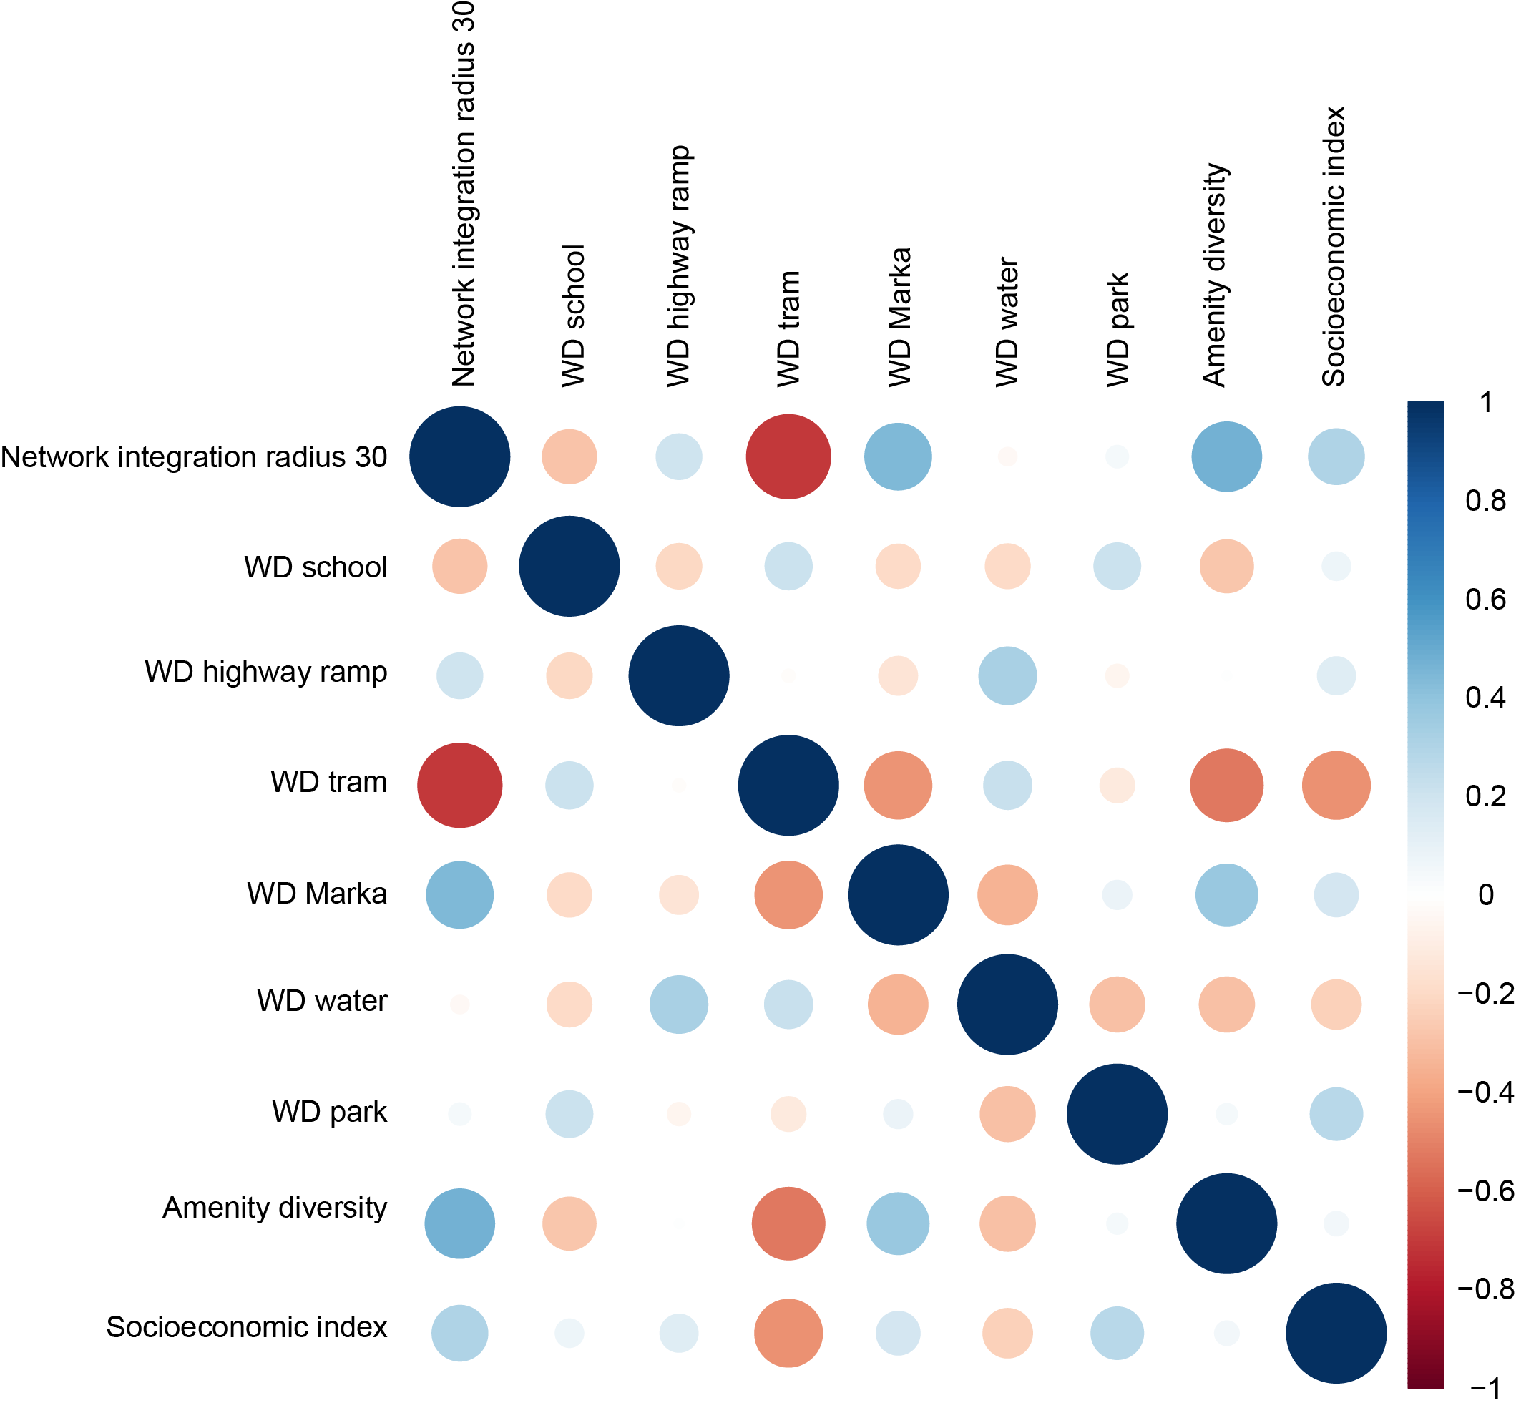
Figure 3. Correlation matrix for all spatial variables included in the final model. Showing mild internal Pearson correlation apart from WD to Tram and Network integration R30. The two correlate just under the threshold of 0.7.

4. RESULTS
The results from the regression are presented in Table 2, which shows the final model’s estimations. Although much effort has been made to make the model robust, through testing many different variables and the specification of them, the model explains just under half of the variation in square meter prices among apartments in Oslo and overall it coincides with our expectations and previous studies.

As has been described before, we used dummies for every sales year to capture fluctuations in prices over time, and it is obvious that the prices increases over time with exception for 2008, due to the global recession. Year dummies reveal a negative impact of the 2008 financial crisis on apartment prices relative to 2007. Apartment prices recovered and exceeded their 2007 levels after 2010.

The size of an apartment has a negative effect on square meter price, which has been commonly observed in the market. The number of bathrooms has a positive effect on square meter price. Toilets and number of rooms in the apartment is highly correlated with number of bathrooms, and the bathroom variables was chosen because it had the highest effect on the explanatory coefficient. Living in higher floors is positively correlated to average per square meter price. With some exceptions, the higher one lives above the ground floor the higher the price. Adjacent to this it is also estimated to be positive if the building has an elevator.

The combined effect of education level, employment level and income level at census tract level is positive on house prices, as expressed by the socioeconomic index. The socioeconomic composition in the neighbourhood is, satisfactory to our expectations, one of the most stable and positive variables explaining apartment prices.

Walking distance to primary schools (WD to School) is negatively correlated to price, which means that a greater distance is considered negative. This is in line with our expectations.

When searching for the effect of accessibility to public transit, we found that walking distance to tram stop (WD to Tram) was the best fit for the model. Testing both for tram, metro, and commuter rail separately and combined, with dummies for different radii and so on, the walking distance to nearest tram stop is the most important determinant for apartment prices in Oslo. Even though walking distance to the nearest tram stop being most prominent factor was a bit surprising, the positive effect of being close to public transit was in line with our expectations.

Walking distance to highway ramps (WD to Highway Ramp) is positively correlated with price, and even though this is expected for access to a disamenity it is suggested, since we are Walking distance to primary schools is negatively correlated to price, which means that a greater distance is considered negative. This is in line with our expectations.

Walking distance to the natural reserve, Marka, is negatively correlated with price, as expected.
Walking distance to open water is negatively correlated with price, in line with expectations and previous studies (Traaholt 2014; Lundhede et al. 2013; Ståhle and Bernow 2011).

Due to high collinearity between the space syntax measure tested and estimated to have an effect in the model, only one could fit in the final model. Global network integration (Network integration R30) was the most robust of them and had the highest effect on explanatory coefficient. Network integration on radius 12 also had a positive but less stable effect on apartment prises, while radius 3 had a negative but stable effect, when the other two were excluded. Angular choice on radius 2, 5, and 10 kilometres was tested but did not have enough effect on the prices to be included in the final model.

Two of the variables did not turn out as we expected; walking distance to park and amenity diversity, where an increased distance to park is considered positive and a greater diversity of urban amenities within 500 m walking distance is considered negative according to the model.

Variable¹ Coefficient² Standard Error
Intercept 11.47**** 0.04
Sold in 2008³ -0.02**** 0.01
Sold in 2009 0.01* 0.01
Sold in 2010 0.06**** 0.01
Sold in 2011 0.14**** 0.01
Sold in 2012 0.20**** 0.01
Sold in 2013 0.26**** 0.01
Sold in 2014 0.30**** 0.01
Sold in 2015 0.40**** 0.01
log(Apartment Living Area⁴) -0.28**** 0.00
Number of Bathrooms 0.15**** 0.00
Located on 2nd Floor⁵ 0.04**** 0.00
Located on 3rd Floor 0.06**** 0.00
Located on 4th Floor 0.08**** 0.00
Located on 5th Floor 0.11**** 0.00
Located on 6th Floor 0.13**** 0.01
Located on 7th Floor 0.19**** 0.01
Located on 8th Floor 0.16**** 0.01
Located on 9th Floor 0.17**** 0.02
Located on 10th Floor 0.18**** 0.02
Located on 11th Floor 0.22**** 0.02
Located on 12th Floor 0.21**** 0.03
Having Elevator 0.06**** 0.00
Network Integration R30 0.09**** 0.02
log(Walking Distance⁶ to Primary School) -0.01**** 0.00
log(Walking Distance to Highway Ramp) 0.03**** 0.00
log(Walking Distance to Tram) -0.01**** 0.00
log(Walking Distance to Marka) -0.02**** 0.00
log(Walking Distance to Open Water) -0.07**** 0.00
log(Walking Distance to Park) 0.01*** 0.00
Amenity Diversity Index -0.002**** 0.00
Socioeconomic Index 0.009**** 0.00
Number of Observations 42,669.00
Adjusted R² 0.47
AIC 6,398.23
BIC 6,684.05
Notes:
¹ The dependent variable is per square meter sales price of apartments between 2007 and 2015 in Oslo, Norway. The unit is thousand NOK.
² Coefficient estimates that are statistically significant at 0.001, 0.01, 0.05, and 0.1 levels are marked with ****, ***, **, and *, respectively. Numbers in parentheses are standard errors.
³ The year dummy-variables’ coefficients represent the differences between the per square meter price in 2007 and in that year.
⁴ Unit: m².
⁵ The floor number dummy variables’ coefficients represent the differences between located at the ground floor and at the floor that the dummy variable represents, when everything else is the same.
⁶ By walking distance, we always refer to the shortest walking distance in this table.

Table 2. Final estimation table from the hedonic modelling.
5. DISCUSSION
Overall, the results show that attributes of location has a great effect on apartment prices in Oslo, and consequently we can show that how we design our cities matter to people’s preferences revealed in the market. The result also suggests that the specifications of these attributes are important for the estimations to be correct, and should be thoroughly investigated. This is also a novelty of this study. We have tried to investigate and develop all measures of location and not only use them as control variables to investigate some other phenomena.

Space syntax measures has been proven influential on housing prices before (Chiaradia et al. 2009; Ståhle and Bernow 2011; Lundhede et al. 2013; Law et al. 2013; Yang, Orford, and Webster 2016). We argue that our study, in addition to the existing literature, proves that even though many other attributes of location is included in the model, the configurational measures, in particular network integration on radius 30, has a robust and with a positive effect on apartment value in Oslo. In other words, when we control for other attributes of location that are often associated with space syntax, we find that space syntax measures are still an important determinant for apartment prices. Due to the collinear nature of the configurational measures, only one could be included in the model, but overall the integration measures proved to have an effect, however, the significance was little or none among the angular choice measures. Our take on this is that the exponential nature of choice values’ distribution over a network does not capture the presumption that an apartment close to shortest paths should give a premium in price.

Since we transfer the space syntax measures’ value from the network to the sales from the nearest neighbour, we see that even though an apartment is close to a route with very high choice values it might be closest to a segment with very low value, a dead end for example. This is not the case for the integration, where the values are more normally distributed over the network. In further research, the transfer of values from the axial or segment map to the points of sales should be considered thoroughly. We would also like to look closer on the effect on prices for apartments located close to a well integrated street but not precisely on it.

We found a small negative effect of the amenity diversity index in Oslo. Examining Copenhagen, Lundhede et al. (2013) found a similar effect, housing prices correlated negatively with amount of restaurants, bars and cafés within 100 m but positively with variety of amenities within 1000 m. This indicate that vibrant urban life including restaurants and cafés very close to the dwelling are not appreciated by residents (supposedly because of noise or other disturbances) but favourable at slightly longer distance. This could be part of the explanation to why diversity of amenities has a negative effect on prices within 500 meter walking distance. We would like to develop this measure and look at alternative radii to see if our expected positive effect can be met. The issue with non-linear correlation of some locational variables is discussed by Heyman and Ståhle (2013) and is a part of on-going research.

The other variable that contradicted our expectations from beforehand was walking distance to park, which we expected to be negatively correlated with prices, but in this model it was positive. In general, closeness to green is considered to be positive, but it also matters what kind of green and how much. As an example (Sjaastad, Hansen, and Medby 2008) found that maintained urban parks and nature had a premium on prices, but green spaces difficult to use, for example between modernistic slab buildings, actually had a negative effect on prices. Based on this, we think that the definition of park in our study should be developed. The definition used now is publicly owned and maintained parks, but this means that there are many more and larger parks outside of the city centre which causes a centre periphery situation. It would be beneficial to define different sizes and even types of parks to see what the effects would be, beside the investigation of the distance between residence and a park.

In further work, it would be beneficial to use data for building height or number of floors. Not least, the variables for which floor the apartment is located at could benefit if it instead could be a continuous variables stating how many floors from the top level it is. We would also be interested in using height data to approximate urban typology (Berghauser Pont and Haupt 2010). This also coincides with our wish to be able to be more accurate with measures for view, which are not as precise as they could be. However, with building height or number of floors we cannot get the exact location of the apartment and consequently not the exact view, but we will get closer. We could also further investigate the relationship between noise levels, which are modelled at ground level, and the floor level.

We believe that this way of measuring the urban environment in terms of attributes of location, can improve the transmission from the hedonic results to the practice and policy making of urban planners and designers. We will, however, keep investigating more and different locational variables than can contribute to a higher explanatory degree of the model. We will also investigate more advanced specifications of hedonic models to take spatial autocorrelation into consideration.

6. CONCLUSION
It is estimated that spatial configuration has an impact on prices in the apartment market in Oslo, which is in line with previous research in other cities. Most robust is the network integration on radius 30. We can also conclude that access public transit is positively correlated to apartment prices, while private transit is negatively correlated. Access to open water and to the natural reserve Marka is positively correlated with apartment prices.

We believe that we have taken a step further in estimation of hedonic prices due to non-aggregated data and network based measures, and that these additional metric measures even more proves the impact configuration of space has on people’s perception of their surroundings.
REFERENCES
Baranzini, Andrea, José Ramirez, Caroline Schaerer, and Philippe Thalmann, eds. 2008. Hedonic Methods in Housing Markets. New York, NY: Springer New York. http://link.springer.com/10.1007/978-0-387-76815-1.
Berghauser Pont, Meta, and Per Haupt. 2010. Spacematrix: Space, Density and Urban Form. Rotterdam: nai010 publishers.
Chiaradia, Alain, Bill Hillier, Yolandes Barnes, and Christian Schwander. 2009. “Residential Property Value Patterns in London: Space Syntax Spatial Analysis.” http://discovery.ucl.ac.uk/18599/1/18599.pdf.
Farr, Douglas. 2007. Sustainable Urbanism: Urban Design With Nature. 1 edition. Hoboken, N.J: Wiley.
Gehl, Jan. 2011. Life Between Buildings: Using Public Space. Sixth Edition edition. Washington, DC: Island Press.
Gehl, Jan, and Lord Richard Rogers. 2010. Cities for People. 1 edition. Washington, DC: Island Press.
Heyman, Axel, and Bendik Manum. 2016. “Distances, Accessibilities and Attractiveness; Urban Form Correlates of Willingness to Pay for Dwellings Examined by Space Syntax Based Measurements in GIS.” The Journal of Space Syntax 6 (2): 213–24.
Heyman, Axel, and Alexander Ståhle. 2013. “Willingness to Pay for Urban Sustainability.” In . Seoul. http://www.sss9.or.kr/paperpdf/gusd/sss9_2013_ref030_p.pdf.
Hillier, Bill. 1996. Space Is the Machine: A Configurational Theory of Architecture. London, UK: Space Syntax. http://eprints.ucl.ac.uk/3881/.
Hillier, Bill, and Julienne Hanson. 1989. The Social Logic of Space. Reprint edition. Cambridge England; New York: Cambridge University Press.
Law, Stephen. 2017. “Defining Street-Based Local Area and Measuring Its Effect on House Price Using a Hedonic Price Approach: The Case Study of Metropolitan London.” Cities 60, Part A (February): 166–79. doi:10.1016/j.cities.2016.08.008.
Law, Stephen, Kayvan Karimi, Alan Penn, Alain Chiaradia, Y. O. Kim, H. T. Park, and K. W. Seo. 2013. “Measuring the Influence of Spatial Configuration on the Housing Market in Metropolitan London.” In Proceedings of the 2013 International Space Syntax Symposium, Seoul, Korea. Vol. 31. http://www.sss9.or.kr/paperpdf/ussecp/SSS9_2013_REF121_P.pdf.
Lundhede, Thomas Hedemark, Toke Emil Panduro, Linda Kummel, Alexander Ståhle, Axel Heyman, and Bo Jellesmark Thorsen. 2013. Værdisætning af bykvaliteter - fra hovedstad til provins: Tematisk hovedrapport. Institut for Fødevare- og Ressourceøkonomi, Københavns Universitet.
Palmquist, Raymond B. 2005. “Chapter 16 Property Value Models.” In Handbook of Environmental Economics, 2:763–819. Elsevier. http://linkinghub.elsevier.com/retrieve/pii/S1574009905020164.
Rosen, Sherwin. 1974. “Hedonic Prices and Implicit Markets: Product Differentiation in Pure Competition.” Journal of Political Economy 82 (1): 34–55.
Sjaastad, Morten, Thorbjørn Hansen, and Per Medby. 2008. “Bokvalitet I by Og Etterspurte Bebyggelsetyper.”
Ståhle, Alexander, and Roger Bernow. 2011. Värdering Av Stadskvaliteter. Stockholm. http://www.tmr.sll.se/Global/hp_regionala_karnor/kunskapsunderlag/vardering_stadskvaliteter.pdf.
Ståhle, Alexander, Lars Marcus, and Anders Karlström. 2005. “Place Syntax: Geographic Accessibility with Axial Lines in GIS.” In Proceedings, Fifth International Space Syntax Symposium, 131–144. http://www.diva-portal.org/smash/record.jsf?pid=diva2:469861.
Traaholt, Nora Vågnes. 2014. “Valuing Urban Recreational Ecosystem Services in Oslo-A Hedonic Pricing Study.” Master thesis, Copenhagen: Department of Food and Resource Economics, Faculty of Science. University of Copenhagen.
Unwin, David J. 1996. “GIS, Spatial Analysis and Spatial Statistics.” Progress in Human Geography 20 (4): 540–51. doi:10.1177/030913259602000408.
Whitehead, Christine M.E. 2012. “The Neo-Liberal Legacy to Housing Research.” In The SAGE Handbook of Housing Studies, edited by David F. Clapham, William Clark, and Kenneth Gibb, 113–31. London ; Thousand Oaks, Calif: SAGE Publications Ltd.
Whyte, William H. 2001. The Social Life of Small Urban Spaces. New York: Project for Public Spaces Inc.
Yang, Xiao, Scott Orford, and Chris J Webster. 2016. “Urban Configuration, Accessibility, and Property Prices: A Case Study of Cardiff, Wales.” Environment and Planning B: Planning and Design 43 (1): 108–129.

For example, the number of toilets and the number of bathrooms are highly correlated with a correlation coefficient of 0.74. After testing, we choose to include number of bathrooms.
Among the structural variables, we opt to a discrete coding of the effects of floor number to per square meter price because if we were using a continuous coding, we would be assuming that, for example the effect of located in fifth floor was twice as much as the effect of located in the first floor, which would be wrong.

