Efficient Use of Virtual and Mixed Reality in
Conceptual Design of Maritime Work Places
Kjetil Nordby, Oslo School of Architecture and Design, Oslo/Norway, kjetil.nordby.aho.no
Stian Børresen, state.space, Bergen/Norway, stian@statespace.no
Etienne Gernez, Oslo School of Architecture and Design, Oslo/Norway, etienne@opensailing.net

Abstract

We present a system that enables real time scanning of human avatars for use in virtual reality supported design processes. The system uses off-the-shelf 3D sensors to generate high-density 3D meshes and high resolution textures of human beings in real-time. Designers can insert real time avatars in virtual scenes using a game engine. Informal preliminary tests of the system, in context of ship bridge design, suggest that the system is capable of enabling effective human-to-human communication in virtual reality supported participatory design.

Supporting participatory design processes

Immersive virtual reality (VR) technologies enabled by head mounted displays (HMD) are gradually becoming a viable tool in maritime design. Human-to-human communication is an important part of such processes. Rich and natural communication among participants have been difficult to achieve with current technologies since HMD-based systems mainly offer single user experiences. To meet such a challenge we present a system enabling human-to-human communication in VR, Fig. 1.

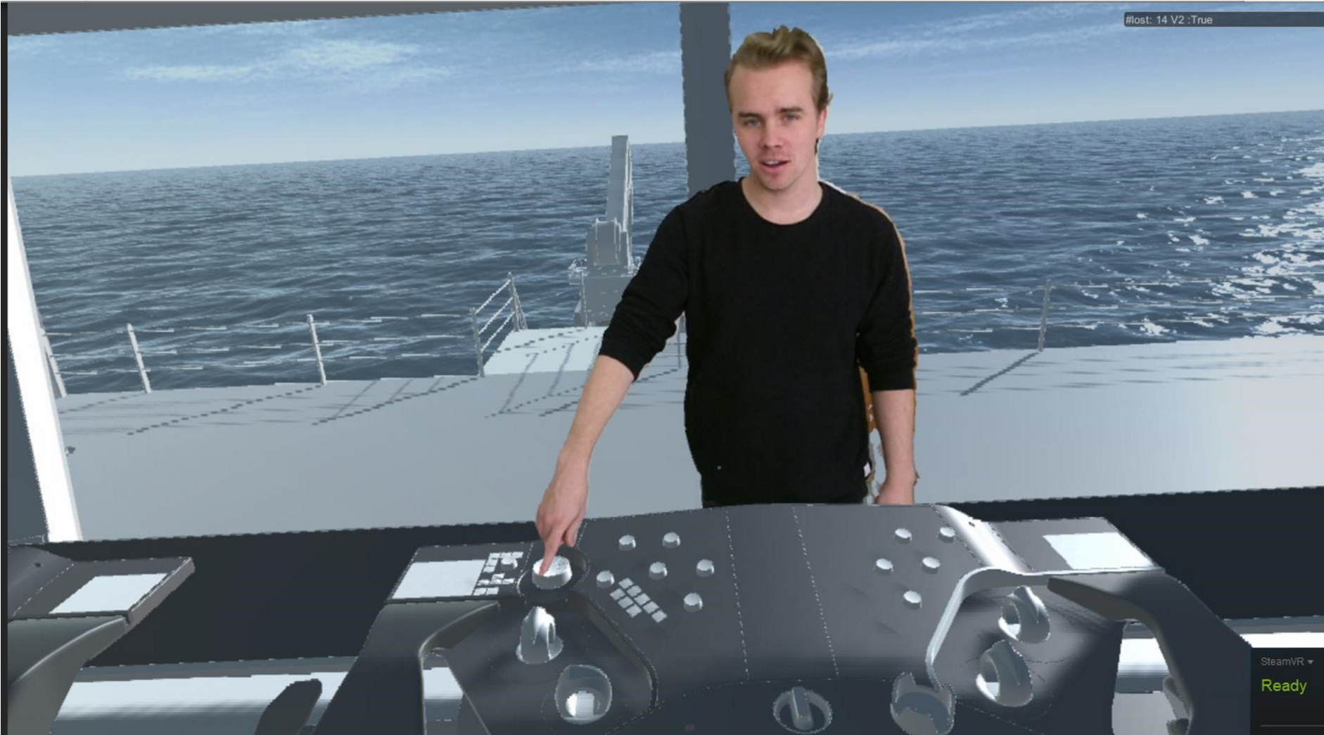
Fig. 1: Screen capture from the HMD supported VR system showing a designer presenting a ship bridge concept to a user (user in 1st person view)

When designing for maritime workplaces, such as ship bridges, there is a need to understand new design proposals according to maritime operational contexts. To make sure the designed systems are adapted to people’s needs, companies employ participatory design processes where users and professional designers collaborate in forming the new workplace, Sanders and Stappers (2008). Such processes take advantage of mariners’ knowledge to improve usability and increase innovation in maritime design.
15th International Conference on Computer and IT Applications in the Maritime Industries, Lecce, 9-11 May 2015, Hamburg, Technische Universität Hamburg-Harburg, 2016, ISBN 978-3-89220-690-3.

Reproduced with the kind permission of the Technische Universität Hamburg-Harburg

To engage mariners in the design process, it is necessary to use tools to mediate the future context. For instance in ship bridge design, designers may use a wide variety of digital and analogue tools to visualise the design proposal and to enable a discussion of design options, Bligård et al. (2014). Österman et al. (2016) compared the use of scale models, 1-1 models, 2D drawings and CAD drawings for use in collaborate ship bridge design. Their work show that, although user preferred 1-1 models, each medium has strengths that designers may use at different stages in a design process. Their work underlines the importance of the moderator role in facilitating discussions among users and designers in participatory design, for example using visualisation tools.

Real-time 3D renderings are now at a point where we can achieve comprehensive real time visualizations of future products to support participatory design. This is well known in the maritime industry where the use if ship simulators is common, Kristiansen and Nordby (2013), and VR has been researched for many years, e.g. Zini et al. (2000), Venter and Juricic (2014). Also, research from other fields show that virtual worlds can effectively support collaborative conceptual design in architectural design, interior design and user interface design, Koutsabasis et al. (2012). Hjelseth et al. (2015) explored the use of game engines for collaborate maritime design. He used 3D models as tools helping contextualise the design discussions between the designer and the expert user. His work emphasises how technologies can support communication in user collaborative design processes.

Immersive VR are not as widely used in maritime design as in other comparable fields such as automotive or aviation. However, the barriers for adopting new technologies in maritime design are lowering, and it is likely that immersive virtual reality can become a viable tool also in design processes for the maritime industry, Morais et al. (2011).

Communication in immersive virtual reality

VR concern a series of technologies that together allow people to immerse themselves in a virtual, computer-generated world. Recent commercial systems such as HTC Vive, htcvive.com/us, and Oculus Rift, www.oculus.com/en-us/rift/, include spatial tracking that transfer user’s motion in real space to the virtual space. Users can interact in the virtual world using a wide variety of tools such as optical tracking of body or specialised physical equipment. Recent VR technologies are now at an affordable level and offer a quality of immersion that may lead people to achieve presence; the feeling of being physically situated in a virtual space as opposed to the physical world, Slater and Wilbur (1997). Such presence is important in allowing users to focus on the design proposals at hand in the virtual environment and not the technologies communicating the virtual environment. Maintaining such presence is a problem when communicating with users in a single user immersive VR scenario. Since the user is alone in the VR environment, the feeling of presence may dissolve when the user becomes aware of voices emerging from outside the virtual environment. We have regularly experienced this break in our VR lab.

We can meet the communication problem by introducing human representations (avatars) in the virtual space to support communication. Realistic avatars (visual and behavioural realism) improve social co-presence in a virtual world, Kang and Watt (2013). Such avatars are usually built manually in CAD software or created with 3D scanners. The avatars are then rigged with a skeleton system, making it possible to animate them.

Even though predefined avatars can convey human presence in VR, they are seldom able to transfer believable body and facial motion. This is a problem since with high model fidelity, users also expect high behavioural fidelity. Avatars that are close, but fail to, achieve users’ expectations of visual and behavioural realism may lead to low acceptance of the avatar. This phenomenon is often referred to as the uncanny valley, Mori and Kageki (2012). The VR industry is very aware of this problem and recently chief scientist at Oculus, Michael Abrash, wrote: “Perhaps the most important problem yet to be solved is figuring out how to represent real people convincingly in VR, in all their uniqueness.” https://www.oculus.com/en-us/blog/welcome-to-the-virtual-age/.

Scanning of human bodies using low cost 3D scanners such as the Kinect, Zhang (2012), can be used to create realistic avatar models, Tong et al. (2012). Although such models have high visual fidelity, they lack in behavioural fidelity. New developments in real time scanning meet this challenge by capturing the 3D mesh and the surface texture, combining them and transferring them to a virtual environment in real-time. This technique results in a mixed reality setup where high visual fidelity is traded for high behavioural fidelity. There are some examples of such technologies in research, Suma et al. (2011), http://doc-ok.org/?p=965, however we know of no tools offering this functionality to designers. We suggest it is useful to investigate such tools to be able to develop knowledge of how we may efficiently adapt virtual reality technologies to participatory design processes.

Prototype system
Our proposed system is developed by the Oslo School of Architecture and Design and state.space Ltd. The system comprises a room-scale VR setup, Fig. 2, realised through the HTC Vive developer edition VR system, which allows free movement in a 5x5m physical space. The HTC Vive system captures the user’s motion in real time and transfers it to the Unity 5 game engine, which renders the environment on the HMD, thus generating an illusion of 1:1 motion in a virtual world.

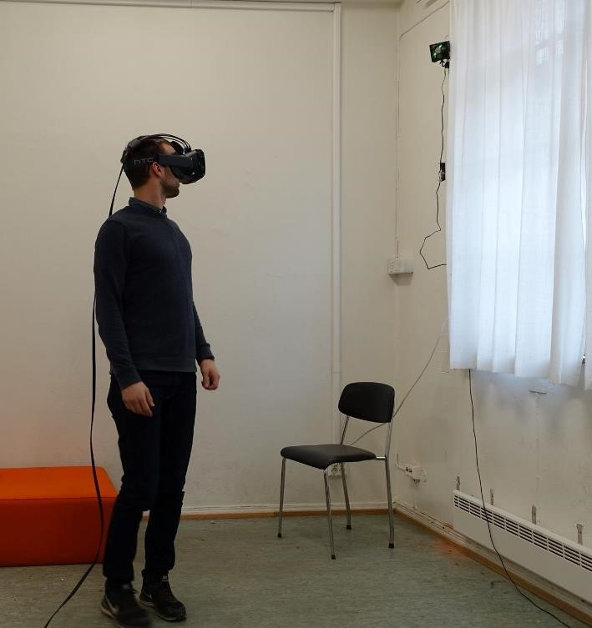
Fig. 2: HTC Vive developer version. Top right: one of two sensors enabling full room tracking

Our system takes advantage of low cost 3D scanning equipment (Kinect 2.0) to detect people standing in front of the sensor and translate the depth and image data into a high poly, fully textured, 3D avatar rendered and animated in real time in Unity 5. Transforming the raw data delivered by the Kinect sensor to a 3D mesh in Unity is done in several steps repeated 30 times per second. As the capture rate of the sensor is limited to this frequency, it is vital to decouple the scanning process and rendering loop of the game engine, which has to run at 90 Hz to provide a comfortable VR experience. First, the RGB pixels from the color camera are converted to a texture map and applied to the material used by the game objects in unity. The depth values are then separated into pixels belonging to any scanned human, and those that are part of the background. The depth values are mapped into x, y, and z coordinates in the coordinate system used by Unity, and after triangulation, the meshes are rendered to the scene. The system is able to scan up to six people simultaneously, and separates the people from the background by utilizing the human detection capabilities that are part of the Kinect SDK.

Our system has two representations in Unity 5. The first is the representation of the Kinect scanner in the virtual scene, Fig. 3a. The second appears as an avatar in the scene, when someone enters the physical scanning areas and is detected as human (by the Kinect software). The human entering the real scene appears in the virtual scene relative to the virtual 3D scanner object, Fig. 3b. After the users have spawned in the 3D world, they can be treated as independent objects, Fig. 3b, making it possible to transform and move them freely and independently from each other. This allows populating a virtual scene with up to six independently positioned real-time avatars. The scanned person facilitating the design session has access to a screen where he or she can see what the VR users are looking at through the HMD, Fig. 4. This gives scanned users the ability to control how they appear and allows them to control their motion in virtual space. The scan area spans a 5 m radius, making it possible for the avatar to walk around in a large fan shaped area inside the virtual model, Fig. 5c.

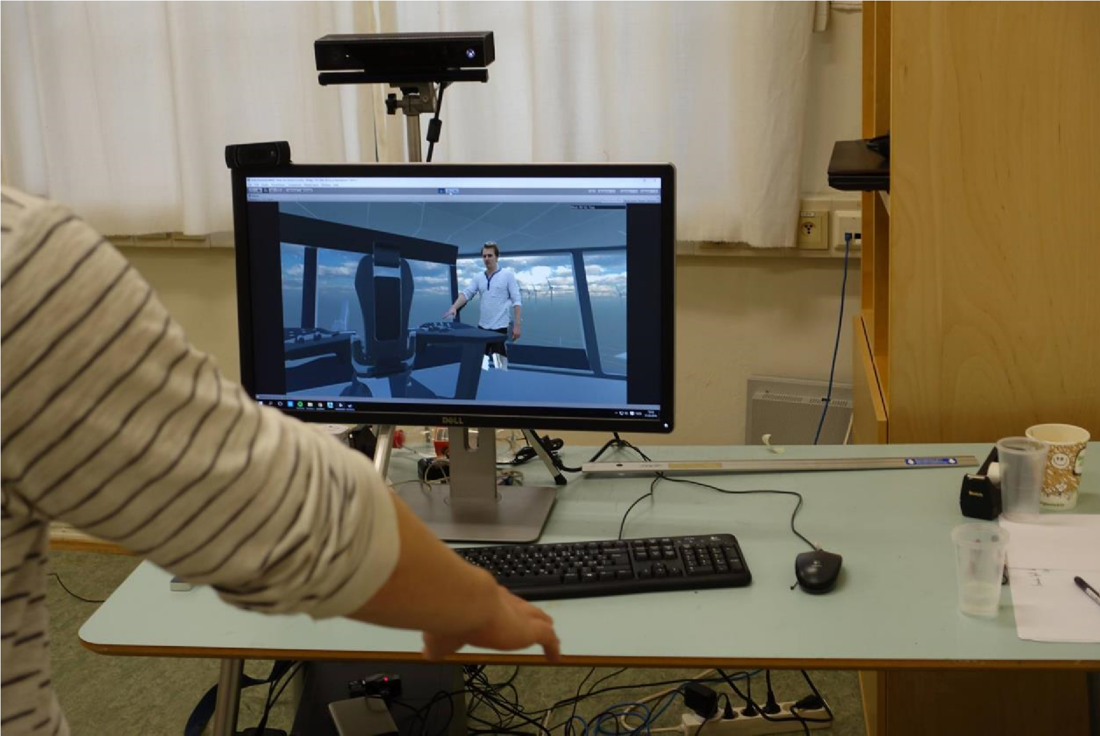
Fig. 4: We have placed the Kinect scanning the facilitator right over a screen that shows the viewport as seen from the point of view of the VR user.

Using the system in design

We have been using the system continuously since December 2015 as part of a master student project oriented towards design of a ship bridge console for a Wind Farm Support Vessel. During the project, the two master students have produced several iterations of the ship bridge consoles and used virtual reality to involve users and other designers in the design process. The VR model allows users to explore the design proposals in relation to a maritime operation staged in Unity 5.

Setup

When setting up the scene it is important to carefully plan where to place the VR user and the facilitator in the VR scene to support the design session. Due to the limitation in the scanning system and the areas available for free motion, we found it best to place the nearest spot the avatar appear slightly inside the area where the VR user can move freely, Fig. 5a. This limits the effect of lack of geometry on the side and behind the avatar, Fig. 6. In doing so the real-time avatar can only enter a small part of the user’s motion space. However, it can move in a very large area outside user space, Fig. 5c. VR user and facilitator avatars can meet up close at the borders of each other’s motion space, Fig. 5f. In setting up the system in such way, the facilitator could walk up to the ship bridge console, reach over it and even point to specific buttons, Fig. 1. Note how the avatar stands accurately behind the console while the hand pointing on the console is in front of the console. This is possible since the avatar is fully realised in 3D space. The avatar can also direct user’s attention to outside features for the scenario accurately by pointing in 3D space, Fig. 7.

A key feature of the system is the ability to simulate eye contact between the VR user and the realtime avatar. To facilitate such eye contact we placed the screen supporting the facilitator just below the Kinect sensor, Fig. 4. Although ideal eye contact is achieved by looking right into the sensor, we achieve a very convincing eye contact effect by looking at the screen right below the sensor. The effect of eye contact is best when the VR user are close to the virtual representation of the Kinect scanner, Fig. 5b, since at this point the scan area is fully aligned with the virtual scan area.

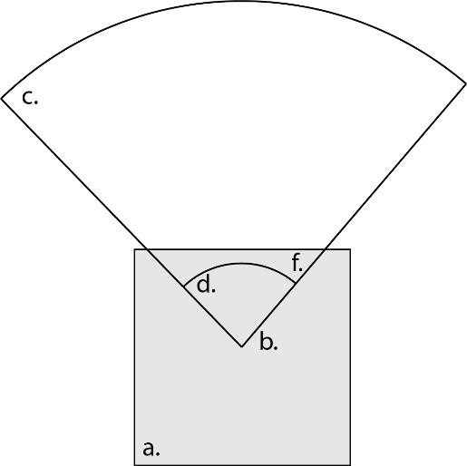
Fig. 5: Top down view of proposed virtual setup of the system. a. Physical space 5x5 m for the user to move physically. b. Virtual placement of the Kinect sensor. c. 8 m radius motion space for scanned facilitator. d. Area where facilitator cannot move due to closeness to sensor. f. Area where facilitator and VR user may meet.

Technical limitations of the real time avatar system

The experienced quality of the system is dependent on several technical limitations and missing features in our test system. The most prominent limitations we met are:
- The image sensor captures 1920x1080 pixels at 30 frames per second (30 Hz). The human figure covers only a small number of such an area making the final texture quality on the avatar much lower.
- The sensor offers a depth map on 512x424 pixels at 30 Hz, which are translated into a mesh that can be displayed in the game engine. Similarly as with the texture, the resolution actually used on the human model is significantly less than the offered height map.
- The depth image has a secondary weakness in the inherent noise in the captured depth data. This translates to small vibrations on the avatar surface that appears when moving up close to the model. While it is possible to use filters to minimize this problem, such filtering can however present additional challenges. It is computationally expensive, making it more challenging to keep the main rendering loop running at a steady 90 Hz. This is important since maintaining a high and steady frame rate is vital to minimize the risk of “Simulator-Sickness” when using VR. More computational steps also mean an increased latency between the movement of the real person and their virtual representation in VR, making the synchronization of the real and virtual world more challenging. Finally, we have experienced that filtering the captured raw data too aggressively can create a sense of unrealism in the final rendered mesh. The smoothed human model starts to look more like a 3D avatar, thus falling back into the “uncanny valley” we are trying to avoid. More experimentation is needed to define where the “sweet spot” of filtering is to be set for applications of this kind.
- Since a camera carries out the human scanning from a single point, the 3D capture is less effective when the scanned person is moving close to the camera. In addition, there will appear geometry “shadows” (occlusion) on the avatar if for instance hands are stretched out in front of the body. Also, the single point capture lead to an incomplete model that deteriorate as the viewer moves to a position where the model can be seen from the side, Fig. 6. We try to limit this problem by positioning the avatar strategically in the scene, Fig. 5.
- The version of the system used did not allow for streaming of scanned avatars over the network. This limits the ability to use the system as a communication medium across distances. Also, the lack of streaming abilities forces us to both scan the model and render the VR scene on the same machine, placing some strain on how we physically arrange the scanning and VR equipment according to each other.
- The version we used did not support playing back captured audio at the correct position in the virtual world. Due to this the scanning sessions needed to be carefully orchestrated, to avoid mismatch between where a person is seen in VR space and the direction where his or hers voice appear to come from. We regularly experience breakdown in immersion when we tested the system with bad alignment of virtual space and the facilitators’ voice position. We will include audio in future version to avoid this problem.

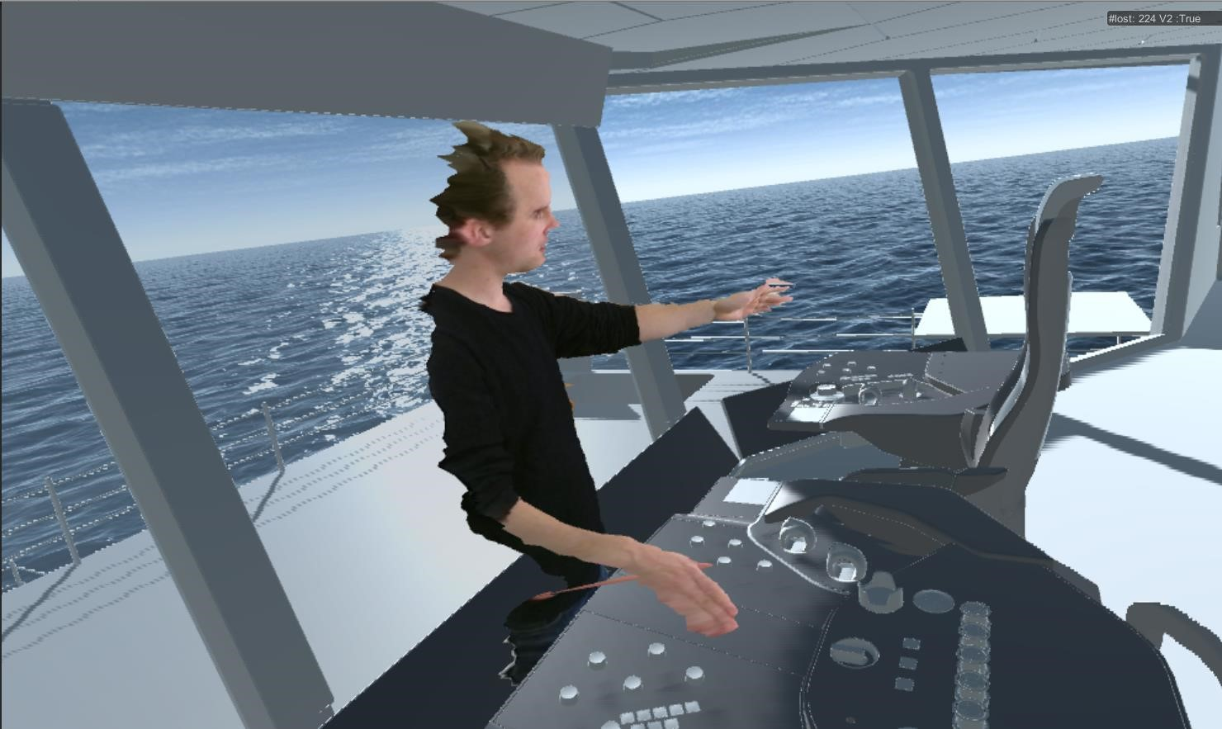
Fig. 6: Real time avatar seen from the side. Screen grab from HMD.

Experiences from using the system in design

The setup process of the system is very simple, and there is little need for technical skill to use the system given basic knowledge of Unity 5. When the virtual scenes are up and running and the Kinect sensor connected, there is no further need to interact with the scanner system. Anybody can enter the virtual scene simply by walking into the scan area in front of the Kinect. In practice, this was a great benefit, since it allowed several facilitators to jump in and out of the VR scene simply by moving in and out of the scanner field. We could also have several people present in the virtual world simultaneously to communicate with the VR user. The simplicity in setup and intuitive use made the threshold for using the scanner in design very low. Because of this, the scanner was always on whenever we used the VR system, both when involving users and whenever the designers were using the system themselves.

In using the system, we found that the real-time avatar allowed VR users to gain a better immersion in the virtual scene. When we had people entering VR without the avatar, they often took off the HMD to be able to talk to the designers directly. This effect was much less prominent when users had a human avatar present to talk to in the VR space.

Eye movement is important in enabling social communication through avatars. Such eye movement was accurately transferred through the system despite the low resolution of the animated texture. In addition, the system simulated convincing eye contact whenever the VR user and the real time scanned avatar were properly aligned, Fig. 1. With avatar and user close to each other, the experience demanded the VR user positioned close to the virtual representation of the Kinect Scanner, Fig. 5c. However, this was less important if the avatar and user were moving further away from each other. We believe it is likely that this contact support user immersion in VR space. However, further tests are necessary to be able to confirm this.

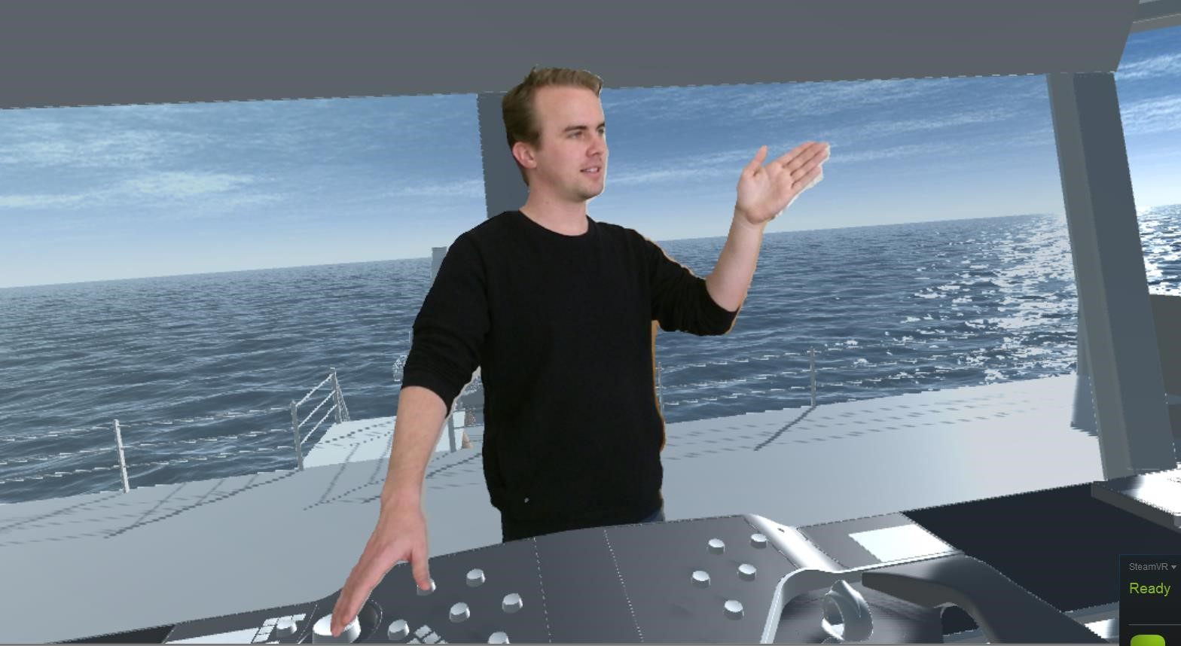
Fig. 7: Screen capture from the HMD showing the real-time scanned avatar

During tests we found that the use of body language was important in three ways. First, it served well in supporting natural conversation with the VR user adding considerable behaviour fidelity to the avatar. Second, it was useful in directing attention towards different areas of the VR model such as design details on the console as well as activities going on outside the ships bridge, Figs. 1 and 6. Third, it offered a sense of scale to the VR scene in addition to the VR users own body. This is important for people reading of the virtual model, Österman et al. (2016). The facilitator could take up positions in relation to the workplace such at the seating position to show the relations between a human body, such as reach, and the design.

The asymmetrical communication setup was experienced as an important limitation in the system. While the VR users are fully immersed, the facilitator can only see the virtual world through the screen, Fig. 4. In addition, seeing oneself through the point of view of another person makes it necessary to have some training in controlling the appearance of oneself. We can improve this experience by adding several view angles to the facilitators screen such as view from above, view from avatar´s perspective, perspective view of avatar as well as view from VR user. Even so, the facilitator experience will not be as immersive as the VR users, making it harder for the facilitator to engage effortlessly in discussions with the VR user.

The system we have developed does not have the same model fidelity as state-of-the-art avatars that usually have more detailed geometry, are complete models and have very detailed textures. However, the state-of-the-art avatars that are accessible for use in design usually have severe limitations in their ability to convey behavioural fidelity, such as detailed body and facial motions. Therefore, most avatars in use in design today fall well within the uncanny valley problem. Our system managed in most instances to avoid the uncanny valley effect. Even though the model fidelity was lacking compared to traditional avatars, the behavioural fidelity seems to compensate. Some users commented on the rough edges of the model, yet most users did not appear to be distracted by the avatar quality. We found that users generally accepted the real-time avatars as acceptable for communication. We think this acceptance is due to the system’s ability to convey human behaviour fully situated in the 3D space.

Conclusion

To be able to use VR efficiently in participatory design processes we suggest there is a need to facilitate good human-to-human communication in virtual space. We have presented a system that supports such communication through real-time scanned 3D avatars. Our current experience from using the system makes us believe that real time avatar are useful in many aspects of participatory design. It may support formal tests, ideation processes and design evaluation. The ease of use of the system makes it possible to add human presence to a VR process with minimum efforts, thus making it a powerful tool for supporting human collaboration in VR space. For design, it allows us to make VR experiences more natural and as such, it supports the efficient communication necessary for efficient design collaboration.

Acknowledgements

Thanks to Hans Martin Erlandsen and Petrit H. Gerxhaliu for contributing the images, testing the system as well sharing their insights in using the VR system. Also, thanks to Ulstein Power and Control for supporting the work.

References

BLIGÅRD, L.O.; ÖSTERMAN, C.; BERLIN, C. (2014), Using 2D and 3D models as tools during a workplace design process–a question of how and when, 11th Symp. Human Factors in Organizational Design and Management (ODAM), Copenhagen, pp. 799-804

HJELSETH, S.; MORRISON, A.; NORDBY, K. (2015), Design and computer simulated user scenarios: Exploring real-time 3D game engines and simulation in the maritime sector, Int. J. Design 9(3), pp.63-75

KOUTSABASIS, P.; VOSINAKIS, S.; MALISOVA, K.; PAPAROUNAS, N. (2012), On the value of virtual worlds for collaborative design, Design Studies 33(4), pp.357-390

KRISTIANSEN, H.; NORDBY, K. (2013), Towards a design simulator for offshore ship bridges, ECMS, pp.212-218

MORAIS, D.; WALDIE, M.; LARKINS, D. (2011), Driving the adoption of cutting edge technology in shipbuilding, 10th Conf. Computers and IT Applications in the Maritime Industries (COMPIT), Berlin, pp.490-502

MORI, M.; MacDORMAN, K.F.; KAGEKI, N. (2012), The uncanny valley [from the field], Robotics & Automation Magazine 19(2), pp.98-100

ÖSTERMAN, C.; BERLIN, C.; BLIGÅRD, L.O. (2016), Involving users in a ship bridge re-design process using scenarios and mock-up models, Int. J. Industrial Ergonomics 53, pp.236-244

SANDERS, E.; STAPPERS, P.J. (2008), Co-creation and the new landscapes of design, CoDesign 4(1), pp.5-18

SLATER, M.; WILBUR, S. (1997), A framework for immersive virtual environments (FIVE): Speculations on the role of presence in virtual environments, Presence: Teleoperators and virtual environments 6(6), pp.603-616

SUMA, E. A.; KRUM, D. M.; BOLAS, M. (2011), Sharing space in mixed and virtual reality environments using a low-cost depth sensor, IEEE Int. Symp. VR Innovation (ISVRI), pp. 349-350)

TONG, J.; ZHOU, J.; LIU, L.; PAN, Z.; YAN, H. (2012), Scanning 3d full human bodies using kinects, IEEE Trans. Visualization and Computer Graphics 18(4), pp.643-650

ZHANG, Z. (2012), Microsoft kinect sensor and its effect, MultiMedia 19(2), pp.4-10

ZINI, A.; ROCCA, A; RAFFA, M.; COSTA, R. (2000), The integration of virtual prototyping in ship design, 1st Conf. Computers and IT Applications in the Maritime Industries (COMPIT), Potsdam, pp.490-502

